**Charge your batteries (Coping Strategies)**

Authors: Justýna, Diana, Tomíno, Anna

Topic: coping strategies, awareness of mental, physical and emotional state

Goals:

* Participants will learn new coping strategies. (Knowledge)
* Participants can use one of the strategies in real life. (Skill)
* Participants will deepen skill of using known coping strategies (Skill)
* Participants will realise the benefit of using coping strategies in real situations. (Attitude)

Target group: 15-30 years (students of universities, high school, young adults)

Materials:

* Printed out lists of activities for each station (mental, physical, emotional).
* Printed out batteries with markers for each participant.
* Dice for each station (2x 6, 2x 8, 2x 12).
* Prepared flipchart with game/activity instructions.
* Prepared flipchart for debriefing/ brainstorming. (+ if needed, flipchart about coping strategies).
* Blocks/pillows arranged in a circle (initial setup).
* Stations (mental, physical, emotional) with prepared materials (papers, pens, markers, images).
* Blank sheets of paper and pens for participants to take notes, Dixit cards
* Speaker, ambient background music.

| **What** | **Why** | **How** | **Time** | **Who** |
| --- | --- | --- | --- | --- |
| Introduction | Create a supportive and welcoming environment. | Introduce the team, topic of the workshop and set the tone for empathetic reflection and learning.   * Seat participants in a circle (on pillows, yoga blocks). * For inspiration see Annex 1. | 5 |  |
| Mindful walking | To connect participants with their current state (recognize their feelings and needs). | Ask participants to stand up and guide them through a mindful (body scan) activity:   * Play background music. * For instructions see Annex 2. * Read each sentence slowly, pausing between each to allow participants to reflect and observe their state. | 5-10 |  |
| Charge your battery | Explore and experience different coping strategies. | Explain the role of the battery according to Annex 3 and rules of the activity. Write instructions on a flipchart.   * Tell instructions according to Annex 3. Use simple language, be prepared to explain in other words. * Have prepared 3 stations: heart, mind, body, with a list of activities (Annex 4) and all needed materials. * During the activity, repeat some of the instructions and let participants know how much time is left. | 20-25 |  |
| Mindful closing | Connect participants with their current state. | Before coming back to the circle, guide participants through a mindful (body scan) activity.   * For instructions see Annex 5. | 2-5 |  |
| Debriefing/ reflection | Realize how different CS affect their mental, emotional and physical state. Share ideas for useful CS. | Facilitate a group discussion to reflect on participants' experiences with CS, realize how CS affects their “battery” and share what other coping strategies they use in real life:   * See Annex 5 with inspiration for questions. * Facilitate group discussion to share CS that participants already use in their daily life. | 15-20 |  |
|  | Total time: | | 60 |  |

**Annex 1 - Introduction**

Today, the four of us will be providing you throughout the workshop we prepared. We will guide you through an activity where you will try and experience different coping strategies. Then we will discuss and reflect on how we apply them in daily life.

**Annex 2 - Mindful walking and brief body scan**

Now I would like to invite you to stand up and wander around. You can walk freely in space. Take your time. Walk slowly, pay attention to the feet, how they are touching the ground.

Feel your breath coming in and out. Observe how your chest is getting up and down. Try to find the place in your body where you feel the breath the most.

When you breathe in, your body is expanding. When you breathe out, feel how your body relaxes.

Observe your mind. Are there any thoughts coming? Just let them come and go and connect back with your body.

How are you feeling? Where in your body do you feel this emotion?

Try to listen to your body. What does it need? Do you have any tensions? Maybe you need a stretch? **Just let the body do whatever it wants.**

If you have your eyes closed, open them and observe the colors around you. Look around the space, maybe your eyes meet with eyes with someone else.

Take your time. And when you feel ready to start the workshop, please come back to the circle.

**Annex 3 - Batteries and 3 CS Stations - Instructions**

**BATTERY:**

*Oral instructions for participants:*

You received a battery with three parts. Each symbol represents a different source/capacity of our energy. There are: 

1. body/physical energy, 🏃

2. mind/mental energy, 🧠

3. heart/ emotional/ soul energy. ♥️ (By emotional scale we mean scale from 0%- unpleasant to 100% - pleasant emotions.)

*Example on the image: At one moment, a person might be (physically) tired - “20% of energy”, feel (emotionally) very content- “90% of energy”, and be mentally prepared to think and learn.*

Now, mark on your battery, where you are now (how your energy levels are).

**3 CS STATIONS:**

*Oral instructions for participants:*

In the following activity, you will experience different coping strategies (CS). CS are ways to work with (regulate) emotions in different situations. We can use CS to manage (reduce) unpleasant emotions.

We have divided strategies **into 3 stations:** 1. body/physical activities, 2. mind/mental activities, 3. heart/ emotional/ soul activities. On each station you will find a list of various strategies/ activities in numbered order and 2 dice. You will walk in space and choose one station (heart, mind, body). When you come to the station, you will choose and try (at least) 1 strategy. How?

You choose the strategy randomly, **by throwing a die.** The dice will choose your destiny. On each station there are two dice. The die with higher numbers represents “more difficult/challenging” tasks.

So once you come to the station:

1. Choose 1 die, ( 1-6 = less challenging / 1-8 =more challenging activities)
2. Throw the die,
3. Try the strategy according to the number on your die.
4. (IMPORTANT) Be aware of your (mental, emotional, physical) state. *Afterwards, notice if and how your battery changes.*
5. If you notice a change, move the marker on your battery.

Additional notes: If you already know the chosen strategy, try to explore it with beginner’s eyes.

If the dice chooses something you do not want to know, you can follow your needs and do what feels right in that moment. We advise you to try at least 1 strategy per station, max 3.

Note to facilitators: Write simple instructions on a flipchart.

**Annex 4 - List of activities for each station - Charge your battery**

**🏃BODY ACTIVITY**

1. Do squats. 20x
2. Jump. 20x
3. Play your favorite song in headphones and dance to it.
4. Shake it off! (shake your hands, legs, body).
5. Stretch what you need.
6. Self-massage.
7. Lie down on the floor.
8. Throw a dice again.

Challenge yourself:

1. Do a yoga position. (choose at least 1, see picture 9)
2. Go out (on a balcony) and breathe in the fresh air.
3. Rub your face with snow.
4. Make a headstand/handstand.

IMAGE no. 9 Yoga positions (example)

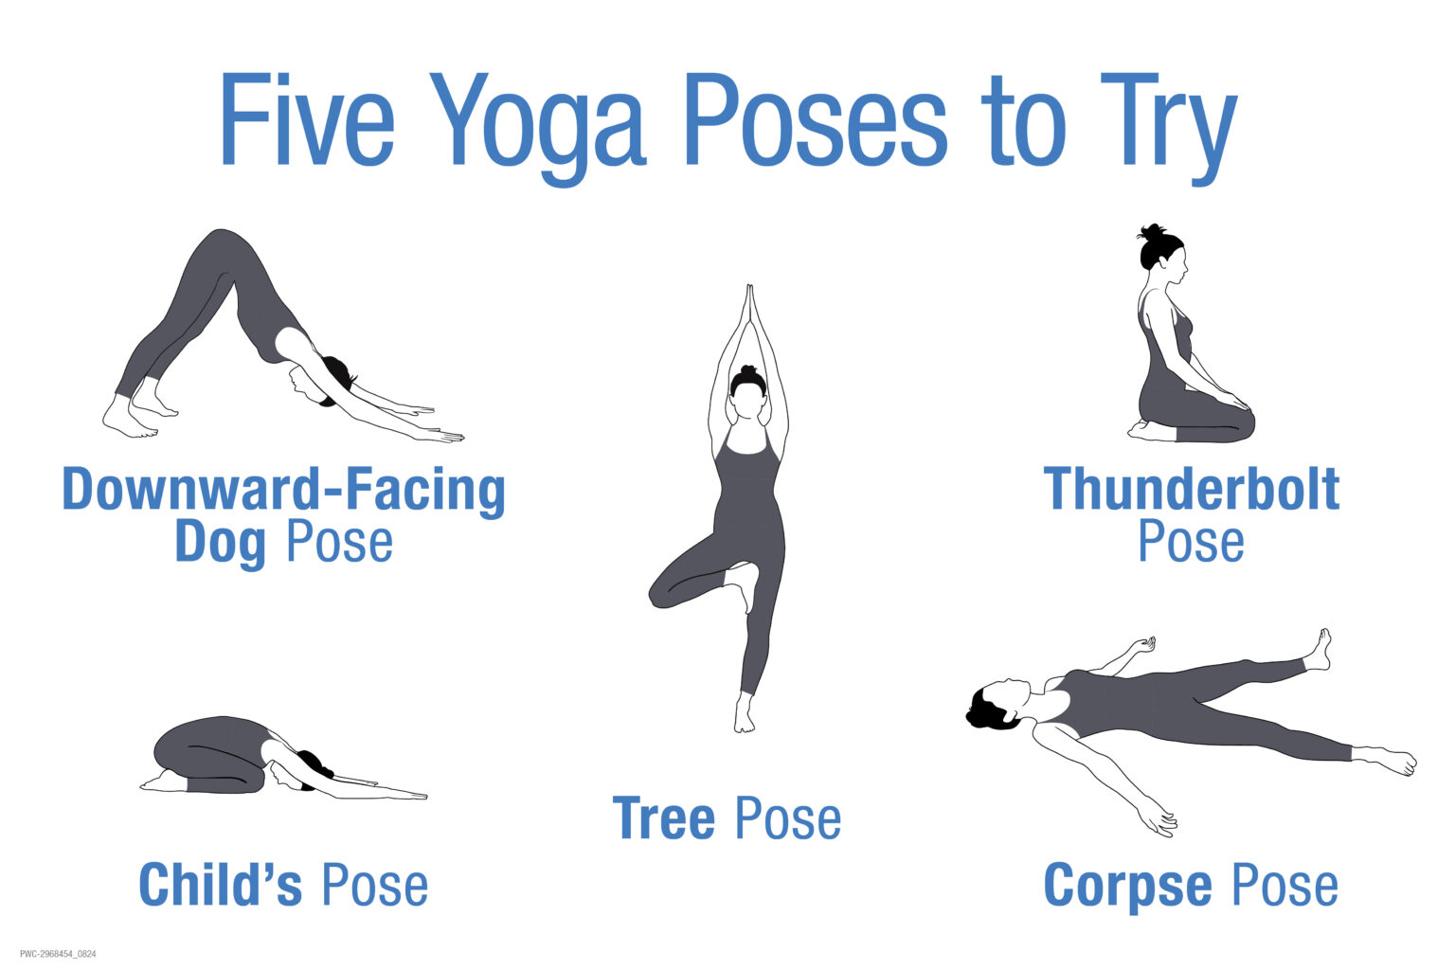

**❤️ HEART ACTIVITY**

1. Hug yourself.
2. Hug someone else (with consent).
3. Self massage yourself.
4. Write down 3 things you are grateful for.
5. Take care of yourself the way you need it.
6. Sit down and take a minute for yourself.   
   (You may close your eyes).

Challenge yourself:

1. Do a box breathing. (see picture 7)
2. Do a triangle breathing (4-7-8). (see picture 8)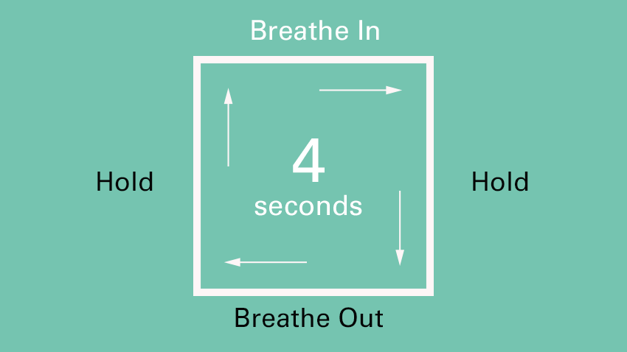

IMAGE no. 7 (You can draw it.) Square breathing.

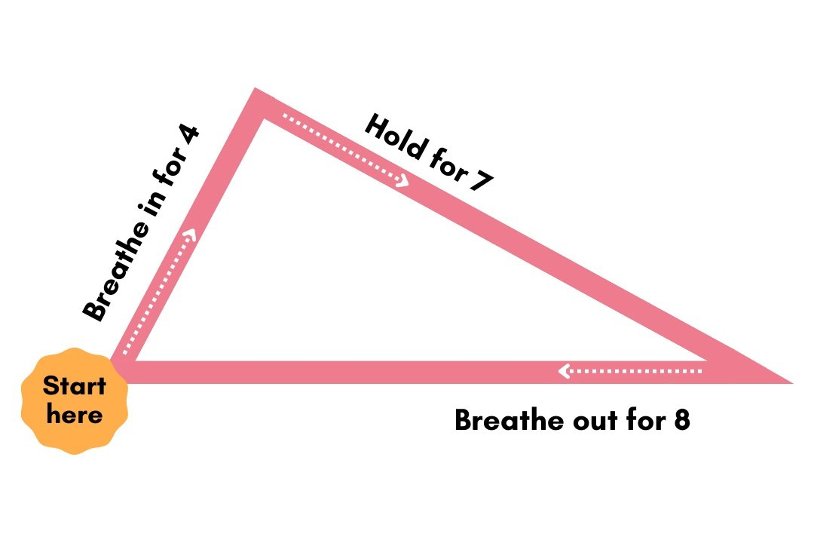

IMAGE no. 8 (You can draw it.) Triangle breathing - 4-7-8.

**🧠 MIND ACTIVITY**

1. Free journaling - write down for 5 minutes anything that comes to your mind. Don’t stop, don’t overthink.
2. Write down 3 things you are grateful for.
3. Write what motivates you in life.
4. Write how you would support your friend in a difficult situation.
5. Choose (max. 3) feelings that describe you now.
6. Write down 3 things you like about yourself.

Challenge yourself:

1. Write: 1. what gives you energy and 2. what drains your energy. (see picture 7)
2. Write down what coping strategies you use that might not be helpful for you.

PICTURE No. 7 (Write: 1. what gives you energy and 2. what drains your energy.)

WHAT GIVES ME ENERGY







WHAT DRAINS MY ENERGY

**BATTERY (for each participant)**



**ANNEX 5 - Mindful closing + debriefing**

*Materials: pillows in a circle, Dixit cards, blank flip chart for brainstorming CS*

Come back to your seats and close your eyes. How do you feel now compared to the beginning of the session? Do you feel more relaxed? Or are there still any tensions in your body? What about your breathing? What are its qualities now? Is your breath maybe calmer and deeper? Just observe it for a while. And what about your emotions? How are you now, compared to the beginning of the session?

Now I invite you to open your eyes. In front of you are dixit cards, maybe some of them reflect your state of being? The process you went through?

You can take the card with you and place it next to your battery.

**Questions for debriefing:**

Now take a look at your batteries? What has changed?

How do you feel now, compared to the beginning? Who would like to share?

Which of the activities was your favorite one?

What coping strategies do you use in everyday life?

We can make a list and inspire each other.

**Tips for Facilitators**